Ex. No. 1 | WORKING WITH WIDGETS AND LAYOUTS
Date of Exercise | 11.08.2026
GitHub Host Link

Aim
To develop a Flutter application using basic widgets and layout widgets such as Container, Row, Column, Expanded, Card, and List View to create a simple student profile/dashboard interface.

Description
Flutter provides various widgets to design user interfaces. In this experiment, basic widgets such as Text, Icon, Container, Row, Column, Card, List Tile, and List View are used to create a student profile application. The application demonstrates how widgets can be arranged using different layout structures.

Procedure:
- Open VS Code and launch the Terminal.
- Check whether Flutter is installed correctly using:

flutter doctor

- Check the available devices using:

flutter devices

- Create a new Flutter project using:

flutter create widget_layout

- Move into the project directory:

cd widget_layout

- Open the project in VS Code:

code .

- Run the default Flutter application:

flutter run

- Open the lib/main.dart file and delete the existing code.
- Import the Flutter Material package and create the basic application using MaterialApp, Scaffold, AppBar, and Text.
- Replace the body with a Column widget and add student information such as student name, department, and laboratory name.
- Add a Container widget with padding and margin to display the student profile.
- Add a Row widget with different icons such as Home, Person, and Settings using
MainAxisAlignment.space Evenly.
- Add Card widgets with ListTile to display information such as Flutter and Mobile Application Development.
- Add a ListView containing multiple ListTile items such as:
  - Flutter
  - Cloud Computing
  - Programming
- Save the program and run the application using:

flutter run

- Observe the student profile/dashboard interface displayed on the selected device.

Program
import 'package:flutter/material.dart'; void main() {
runApp(const MyApp());
}
class MyApp extends StatelessWidget { const MyApp({super.key}); @override
Widget build(BuildContext context) { return MaterialApp( debugShowCheckedModeBanner: false, title: 'Student Profile',
theme: ThemeData(

colorScheme: ColorScheme.fromSeed(seedColor: Colors.blue), useMaterial3: true,
),
home: const StudentProfile(),
);
}
}
class StudentProfile extends StatelessWidget { const StudentProfile({super.key}); @override
Widget build(BuildContext context) { return Scaffold(
appBar: AppBar(
title: const Text('Student Profile'), backgroundColor: Colors.blue, foregroundColor: Colors.white,
),
body: ListView(
padding: const EdgeInsets.all(16), children: [
Container(
padding: const EdgeInsets.all(20),
margin: const EdgeInsets.only(bottom: 15), decoration: BoxDecoration(
color: Colors.blue.shade50, borderRadius: BorderRadius.circular(12),
),

child: const Column( children: [
Icon( Icons.person, size: 70,
color: Colors.blue,
),
SizedBox(height: 10), Text(
'Student Profile', style: TextStyle( fontSize: 24,
fontWeight: FontWeight.bold,
),
),
SizedBox(height: 5), Text( 'URK23CS1272',
style: TextStyle(fontSize: 18),
),
Text(
'Computer Science and Engineering', textAlign: TextAlign.center,
),
],
),

),
const Text( 'Quick Access', style: TextStyle( fontSize: 20,
fontWeight: FontWeight.bold,
),
),
const SizedBox(height: 10), Row(
mainAxisAlignment: MainAxisAlignment.spaceEvenly, children: const [
Icon(Icons.home, size: 35, color: Colors.blue), Icon(Icons.person, size: 35, color: Colors.green), Icon(Icons.settings, size: 35, color: Colors.orange),
],
),
const SizedBox(height: 20), const Card(
child: ListTile(
leading: Icon(Icons.book, color: Colors.blue), title: Text('Flutter'),
subtitle: Text(
'Mobile Application Development',
),
),
),

const Card( child: ListTile(
leading: Icon(Icons.cloud, color: Colors.blue), title: Text('Cloud Computing'),
),
),
const Card( child: ListTile(
leading: Icon(Icons.code, color: Colors.blue), title: Text('Programming'),
),
),
],
),
);
}
}

Output
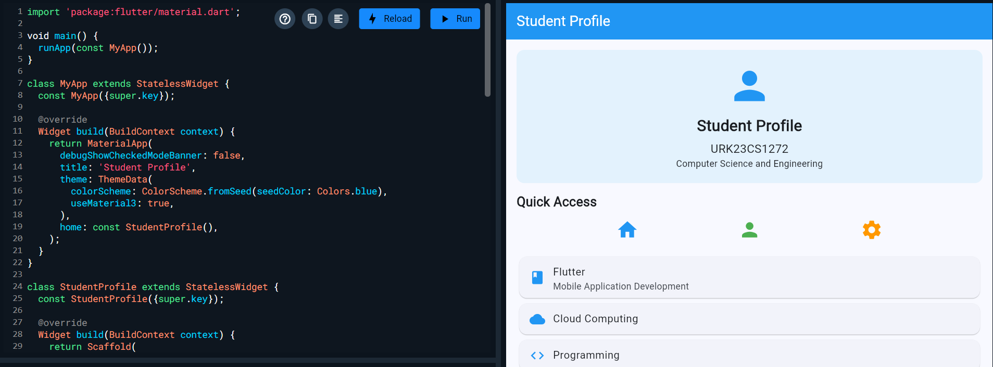

Result
Thus, a Student Profile/Dashboard application was successfully developed using Flutter with Container, Row, Column, Card, List View, and other basic widgets. The application was executed successfully and the expected user interface was displayed.

Ex. 1 | Title of exercise
1

